**Student Experiential Learning**

Report submitted to the

**VIT Bhopal University**

**Integrated Masters of Technology**

**in**

**Artificial Intelligence**

***Submitted by***

**TANISHQ KOLHATKAR**

**Reg No.-21MIIM10025**

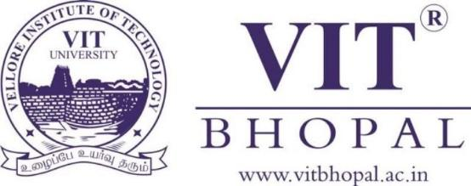

School of Computer Science Engineering

**VIT Bhopal University, Madhya Pradesh**

**October, 2023**

**Declaration**

I, TANISHQ KOLHATKAR, bearing the Registration Number *21MIM100025* hereby declare that this report of “*Experiential Learning*” represents my original work carried out as a undergraduate student at VIT Bhopal University. To the best of my knowledge, it contains no material previously published or written by another person, nor any material presented for the award of any other degree of VIT Bhopal University or any other institution. Any contribution made to this report by others, with whom I have worked at VIT Bhopal University or elsewhere, is explicitly acknowledged in the report.

Date-10-10-23 *Tanishq Kolhatkar*

VIT Bhopal University

**Acknowledgment**

I am writing to express my sincere appreciation for the experiential learning program conducted by VIT Bhopal College in Chennai and Bangalore. The program has been a valuable and enriching experience, and I wanted to take a moment to acknowledge the efforts and contributions of everyone involved.

The program provided me with a unique opportunity to gain practical insights and hands-on experience in Technology, which I believe will be instrumental in my academic and professional growth. The dedication and expertise of the faculty and staff at VIT Bhopal College played a pivotal role in making this program a success, and I am grateful for their guidance and support.

I also want to extend my gratitude to the organizers and coordinators for their meticulous planning and execution, which ensured a seamless and rewarding learning experience for all participants. The choice of locations, Chennai and Bangalore, added an extra dimension to the program, exposing us to diverse environments and real-world scenarios.

**Tanishq Kolhatkar**

**Summary of Your Experential Learning**

During the VITB Experiential Learning program, I had the privilege of embarking on a journey that combined education with practical experiences, offering a well-rounded and enriching learning experience. The program took us to various fascinating places and introduced us to remarkable individuals while providing us with valuable training and insights. Here are the key highlights of the program:

* 1.Tech Talks: The program featured engaging tech talks, where we had the opportunity to interact with industry experts and thought leaders. These discussions allowed us to stay updated with the latest advancements and trends in the technology sector.
* 2.Bangalore Darshan: Our visit to Bangalore, often referred to as the "Silicon Valley of India," allowed us to witness the thriving tech ecosystem of the city. We explored renowned tech companies, startup hubs, and innovation centers.
* 3.Aeroplane Making: An exciting and hands-on experience in the field of aviation. We had the chance to learn about aeroplane construction and even participate in the assembly process, gaining insight into the intricacies of aerospace engineering.
* 4.BSNL Visit: Our interaction with the team at Bharat Sanchar Nigam Limited (BSNL) provided an in-depth understanding of the telecommunication industry, its challenges, and the role of BSNL in connecting the nation.
* 5.Metro Facility Visit: Exploring the Bangalore Metro facility was not only a fascinating journey but also an opportunity to learn about the importance of efficient public transportation systems in urban development.
* 6.Motivate to Innovate Talks: Inspirational talks from successful entrepreneurs and innovators motivated us to think creatively and pursue innovation in our academic and professional endeavors.
* 7.Anna Library and Birla Planetarium: Visiting these cultural and educational landmarks expanded our knowledge and appreciation for science and literature. The Anna Library offered a wealth of resources, while the Birla Planetarium opened up the cosmos to us.

# Contents

**Description Page No.**

Declaration of originality…………………………………

Acknowledgment………………………………………….

Summary ……………………………………………………

Contents……………………………………………………

City Choice – 1 Day – 1 report

* + 1. Industry Name………………………………………….
    2. Objectives ……………………………………………..
    3. Learning outcome………………………………………
    4. Photographs…………………………………………….
    5. Feedback of the day -1………………………………….

Day – 2 report

* + 1. Industry Name………………………………………….
    2. Objectives ……………………………………………..
    3. Learning outcome………………………………………
    4. Photographs…………………………………………….
    5. Feedback of the day -2………………………………….

Day – 3 report

* + 1. Industry Name………………………………………….
    2. Objectives ……………………………………………..
    3. Learning outcome………………………………………
    4. Photographs…………………………………………….
    5. Feedback of the day -3………………………………….

Day – 4 report

* + 1. Industry Name………………………………………….
    2. Objectives ……………………………………………..
    3. Learning outcome………………………………………
    4. Photographs…………………………………………….
    5. Feedback of the day -4………………………………….

Day – 5 report

* + 1. Event/Industry Name………………………………….
    2. Objectives ……………………………………………..
    3. Learning outcome………………………………………
    4. Photographs…………………………………………….
    5. Feedback of the day -5………………………………….

City Choice – 2 Day – 1 report

* + 1. Industry Name………………………………………….
    2. Objectives ……………………………………………..
    3. Learning outcome………………………………………
    4. Photographs…………………………………………….
    5. Feedback of the day -1………………………………….

Day – 2 report

* + 1. Industry Name………………………………………….
    2. Objectives ……………………………………………..
    3. Learning outcome………………………………………
    4. Photographs…………………………………………….
    5. Feedback of the day -2………………………………….

Day – 3 report

* + 1. Industry Name………………………………………….
    2. Objectives ……………………………………………..
    3. Learning outcome………………………………………
    4. Photographs…………………………………………….
    5. Feedback of the day -3………………………………….

Day – 4 report

* + 1. Industry Name………………………………………….
    2. Objectives ……………………………………………..
    3. Learning outcome………………………………………
    4. Photographs…………………………………………….
    5. Feedback of the day -4………………………………….

Day – 5 report

* + 1. Event/Industry Name………………………………….
    2. Objectives ……………………………………………..
    3. Learning outcome………………………………………
    4. Photographs…………………………………………….
    5. Feedback of the day -5………………………………….

Conclusions

# 

City Choice – 1

CHENNAI

**Day – 1 report**

* Industry Name – TOSCA Tool Hands on Training
  + - Objectives- Automates the System
    - Learning outcome- 1. Learn new tools 2. Learn to automate system. 3. Learn to make gmail work automatically using TOSCA tool
    - Photographs (Paste 4-5 good photogrpahs of hands on experience/visit)
    - 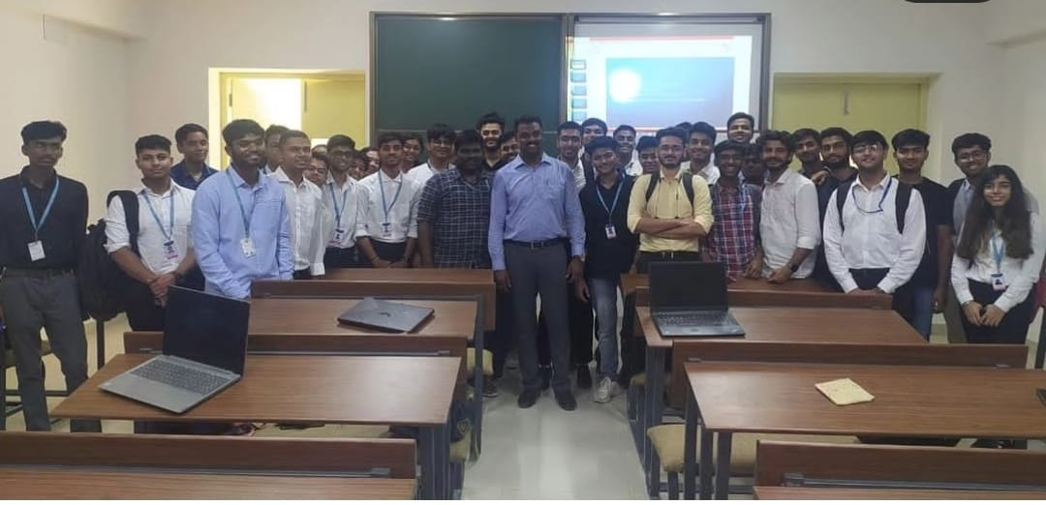

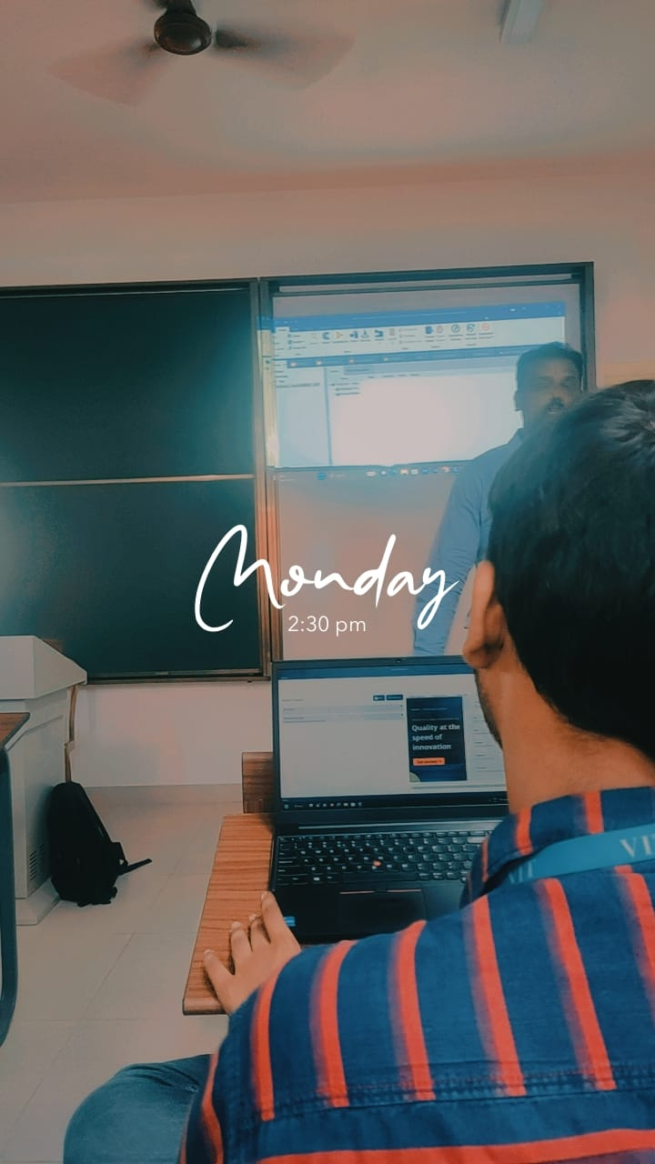

* + - Feedback of the day – Good

**Day – 2 report**

* + - Industry Name – RGMTTC BSNL
    - Objectives- Learn about BSNL and technologies
    - Learning outcome-1 BSNL Office working 2. Optical cable wire working. 3. Antennas 4. MODEM Working
    - Photographs (Paste 4-5 good photogrpahs of hands on experience/visit)

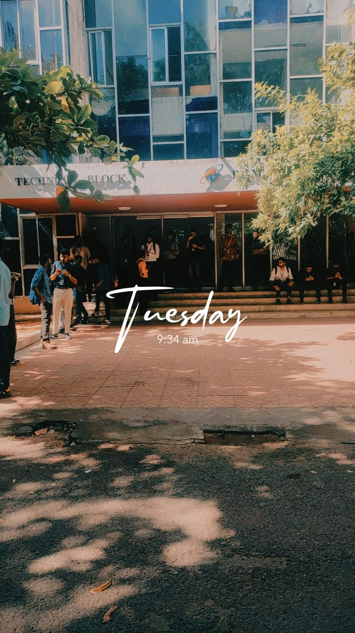

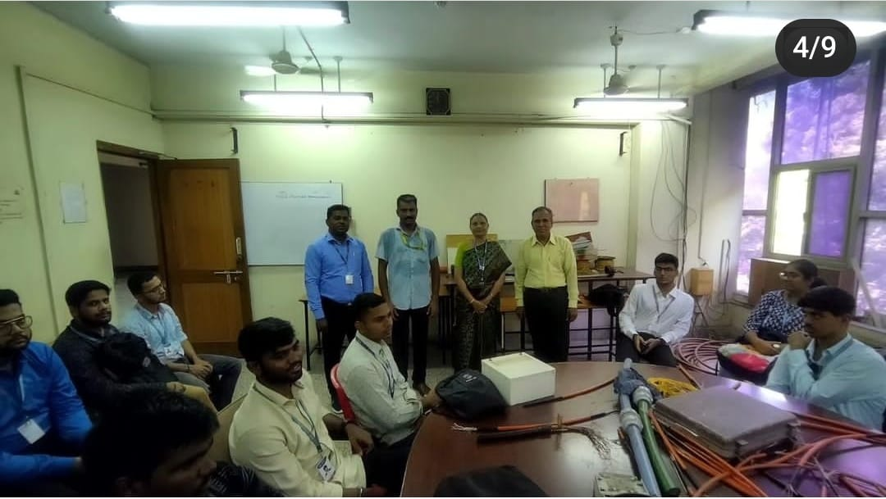

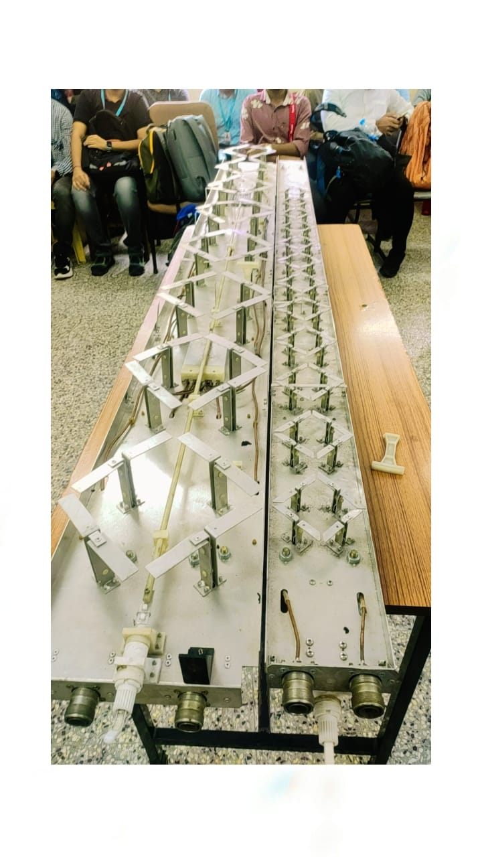

* + - Feedback of the day – good

**Day – 3 report**

* + - Industry Name – Monolith R&D
    - Objectives- To learn about Gaming AR & VR Technology
    - Learning outcome-1 . Benefits of gaming. 2. History of gaming 3. How Gaming remove Adddiction of various kind. 4. VR Headset
    - Photographs (Paste 4-5 good photogrpahs of hands on experience/visit)

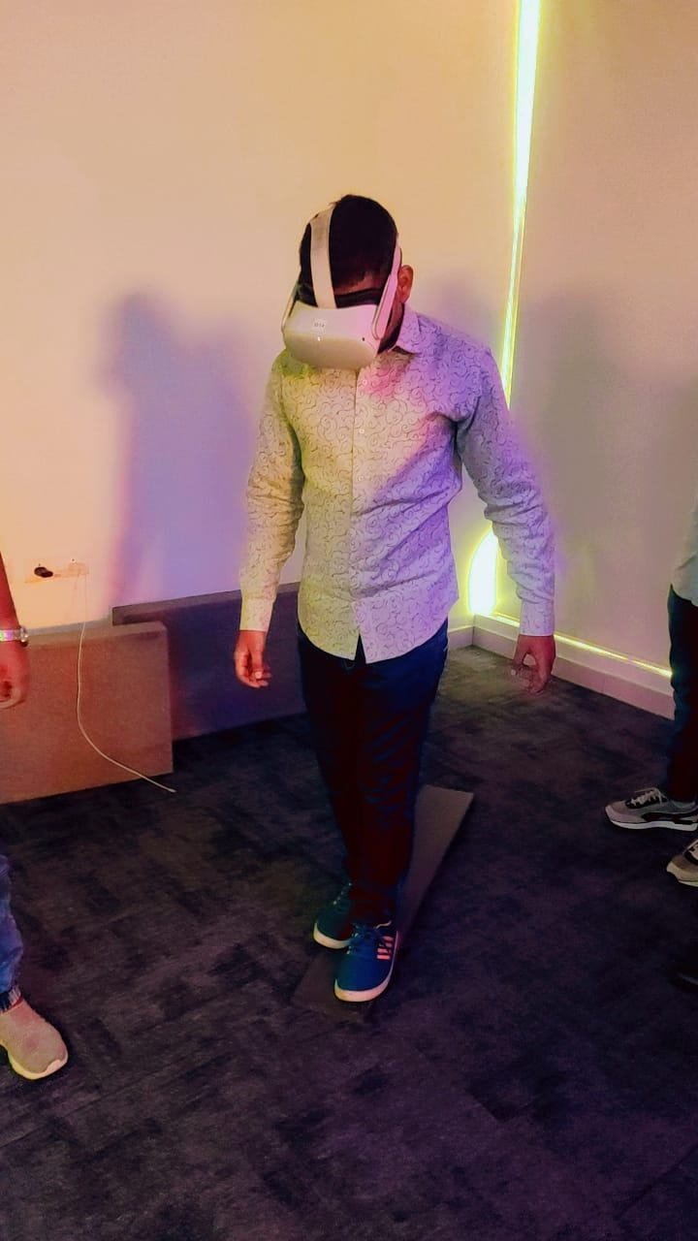

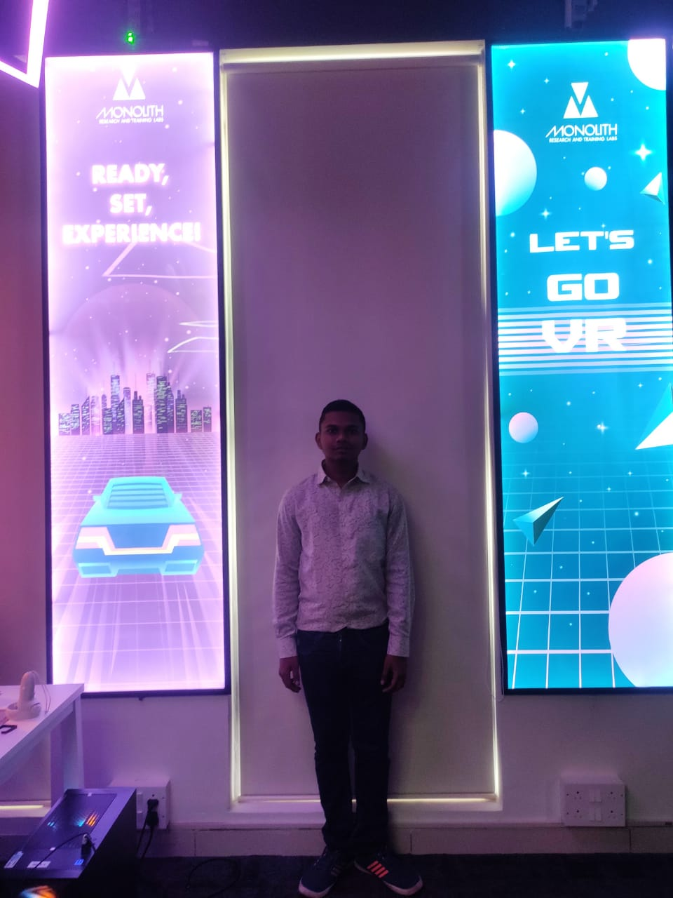

* + - Feedback of the day – Good

**Day – 4 report**

* + - Industry Name – MOTIVATE TO INNOVATE
    - Objectives - Learn to Innovate
    - Learning outcome- 1. Identify Real world problems 2. Find solutions of it. 3. Make Bussiness model out of it. 4. Become Enterpreneur. 5. Two guest speaker motivate by their knowledge and exprience
    - Photographs (Paste 4-5 good photogrpahs of hands on experience/visit)

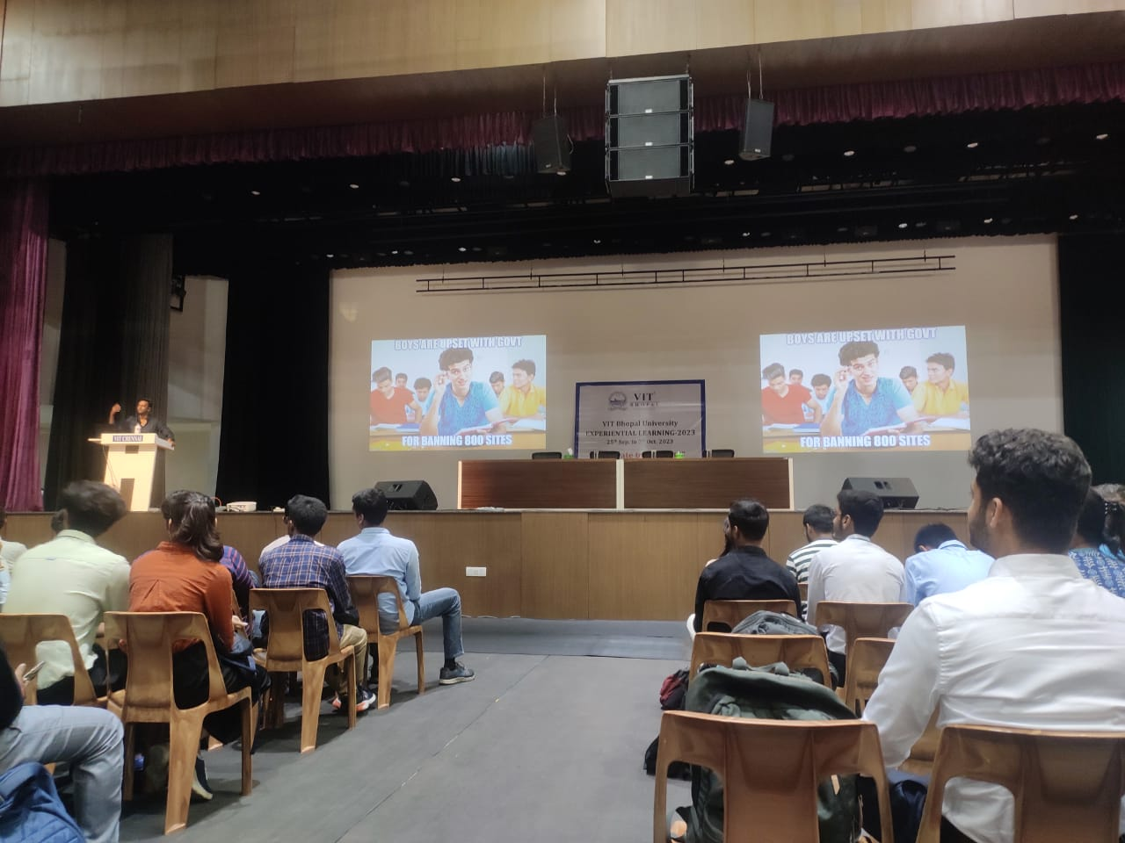

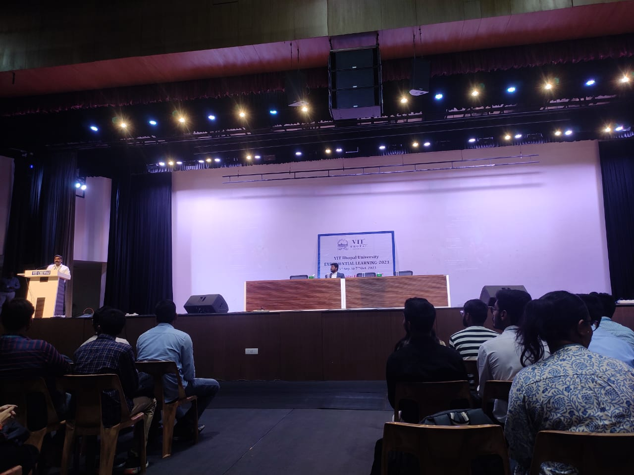

* + - Feedback of the day – 4

**Day – 5 report**

* + - Event/Industry Name – Anna Library And Birla Planeterium
    - Objectives- Learn about Anna Library and Birla Planeterium
    - Learning outcome -1. Learn about various science through experiments 2. Learn about how people study in library for competitive exams 3. Learn about missiles from old to new one ie Bramhos in planeterium 4. Learn about Hearts of various creatures in planeterium
    - Photographs (Paste 4-5 good photogrpahs of hands on experience/visit)

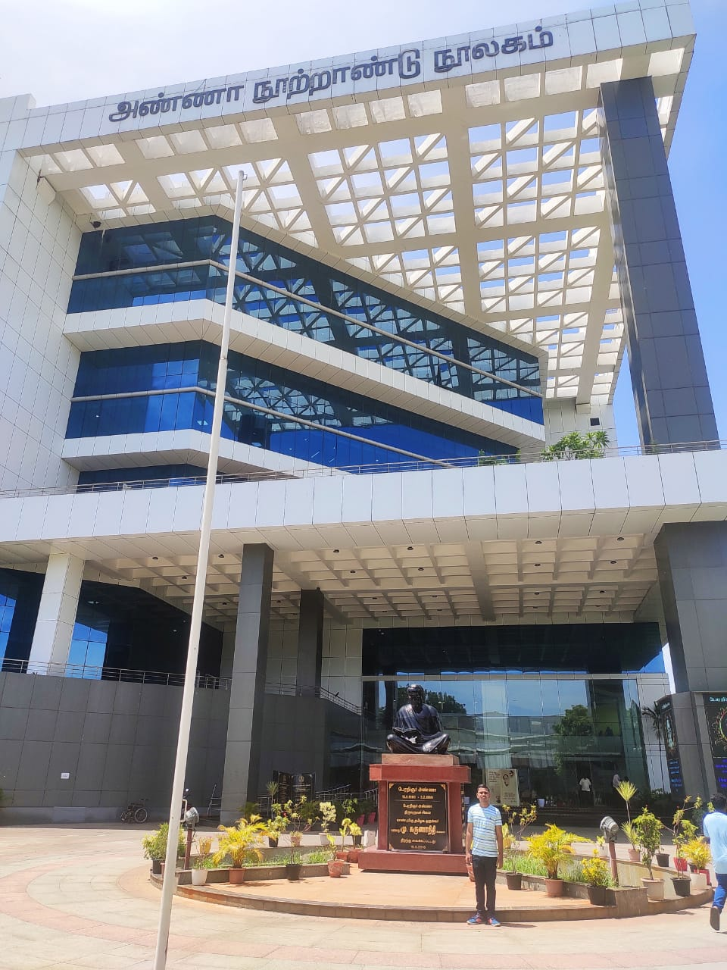

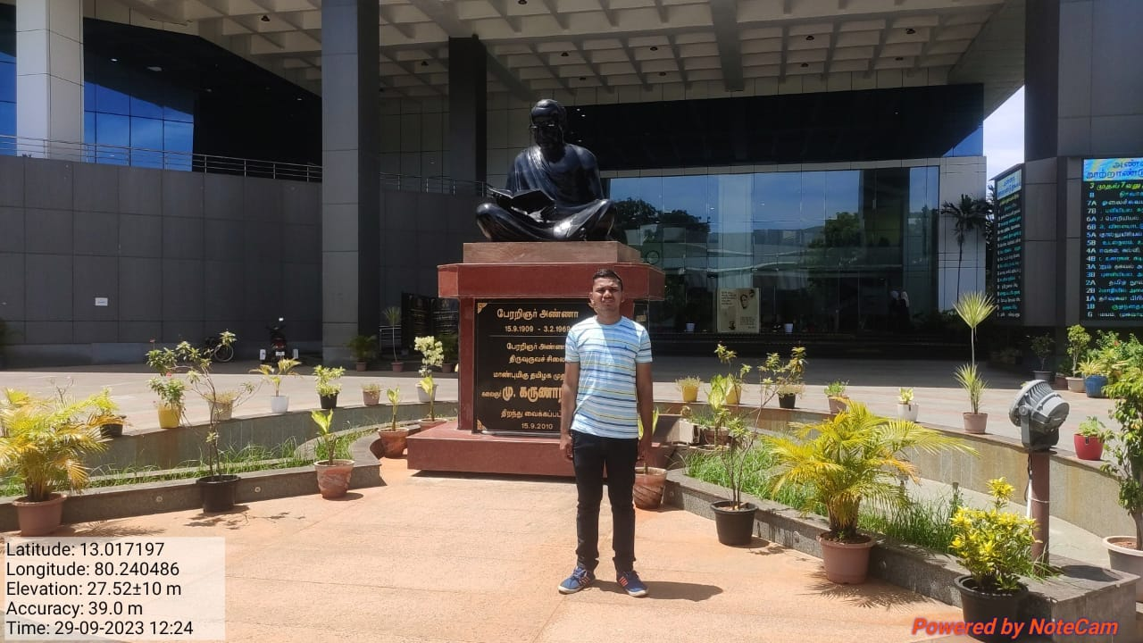

* + - 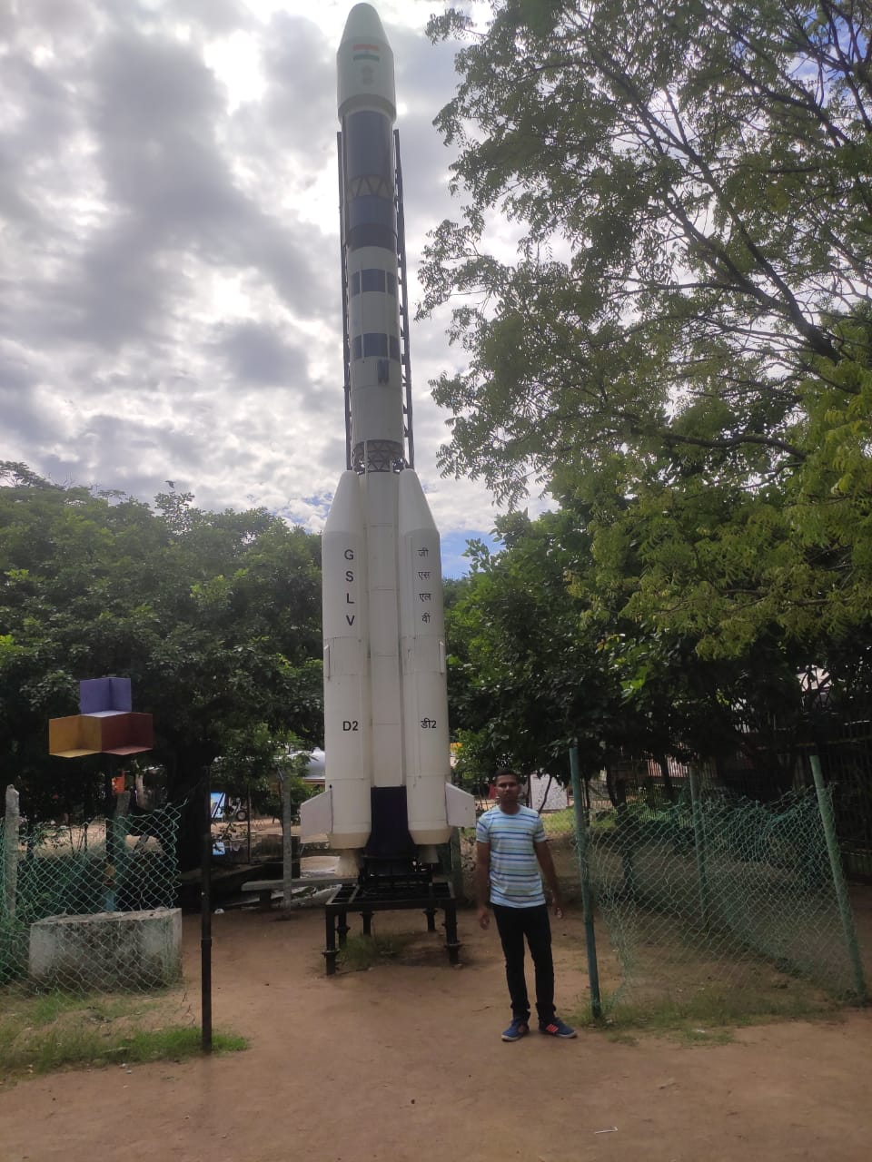
    - Feedback of the day –good

Choice – 2

BANGLORE

**Day – 1 report**

* + - Industry Name – AERONUTS
    - Objectives -Learn to Make Aeroplane
    - Learning outcome - 1. Learn about aeroplane components 2. How to make lightweight aeroplane from PLastics
    - Photographs (Paste 4-5 good photogrpahs of hands on experience/visit)

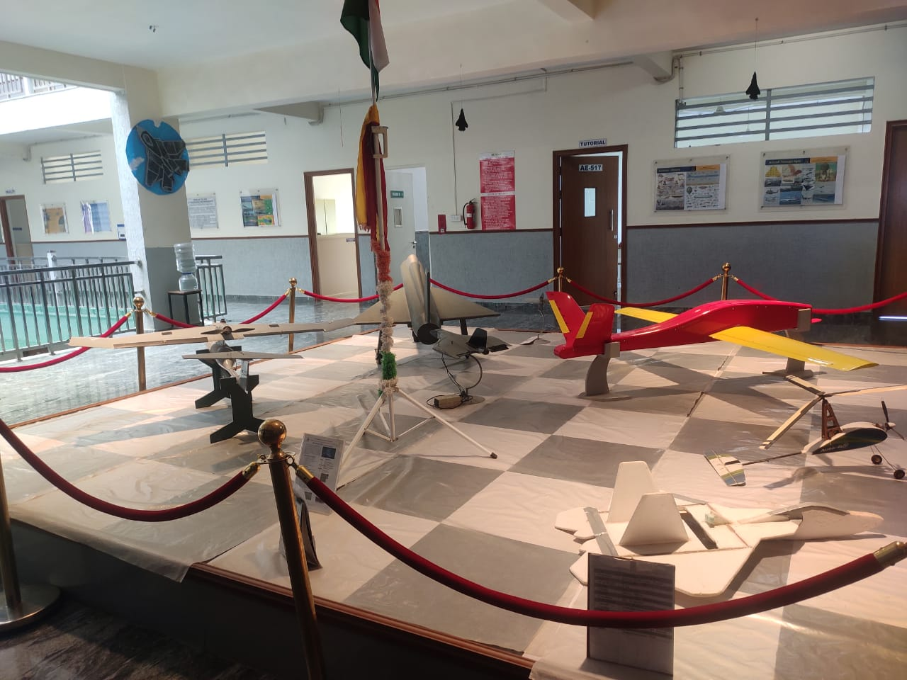

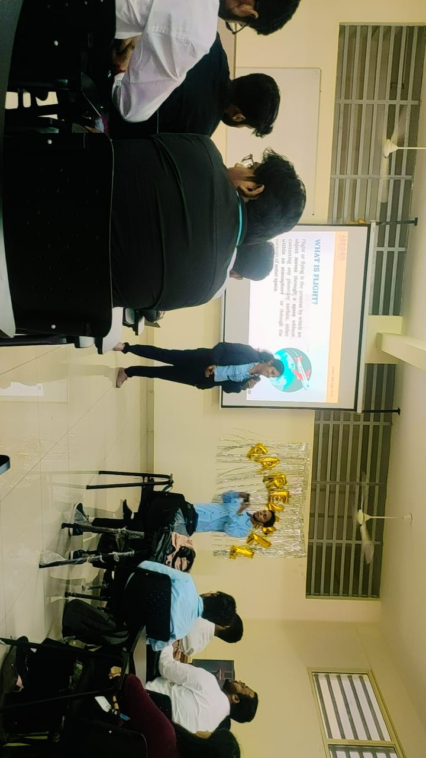

* + - Feedback of the day – 1

.

**Day – 2 report**

* + - Industry Name – AERONUTS
    - Objectives-Learn to Make Aeroplane
    - Learning outcome- 1. How to fit Electric motors in Aeroplane 2. How to design aeroplane 3. How to connect aeroplane using radio technology.
    - Photographs (Paste 4-5 good photogrpahs of hands on experience/visit)

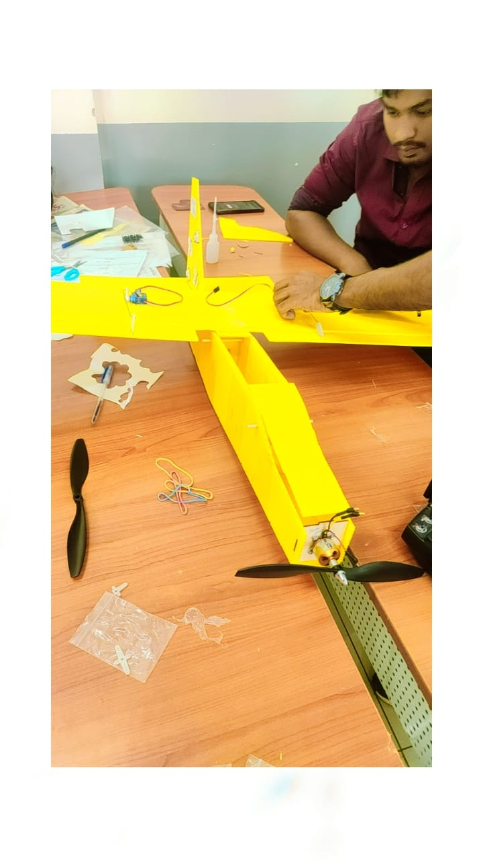

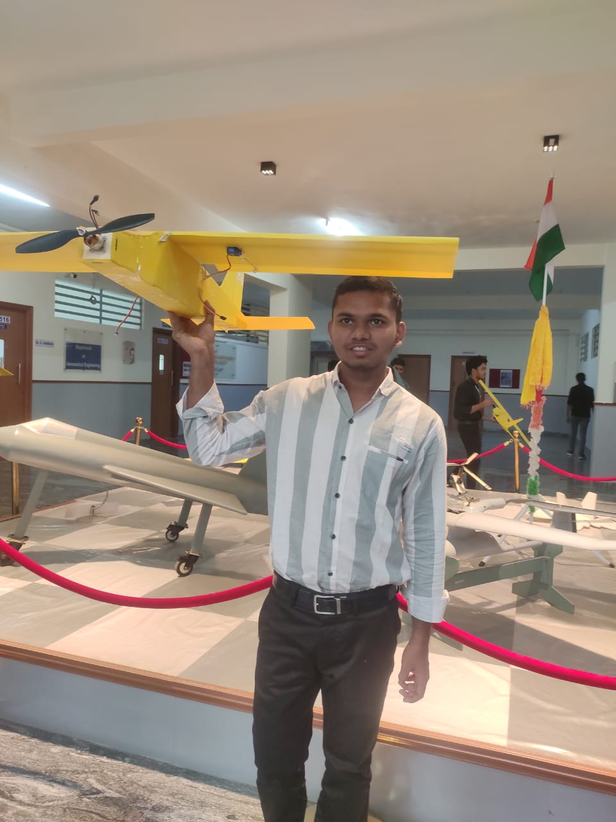

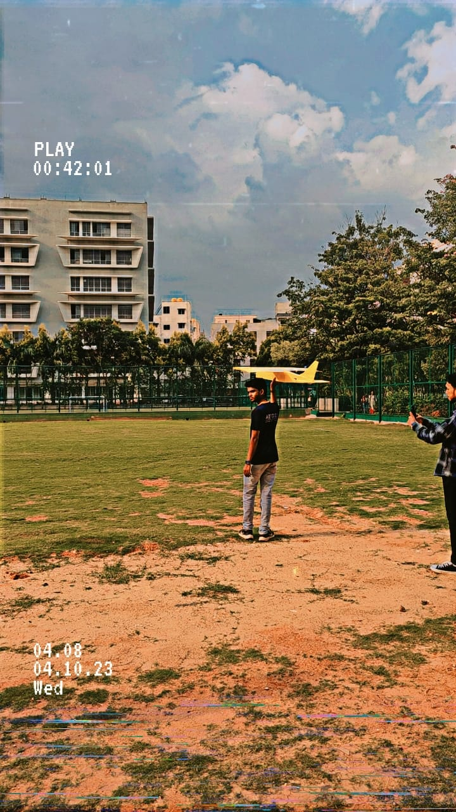

* + - Feedback of the day – good

**Day – 3 report**

* + - Industry Name –BMRCL Operational Metro and OCC Facility
    - Objectives- Learn about Metro Facility
    - Learning outcome- 1. Learn about metro component ie doors, emergency alerts.2. Bangalore metro history and future plans 3. Metro Depot and its Facility 4. Metro brakes and checking facility. 5. Metro control facility
    - Photographs (Paste 4-5 good photogrpahs of hands on experience/visit)

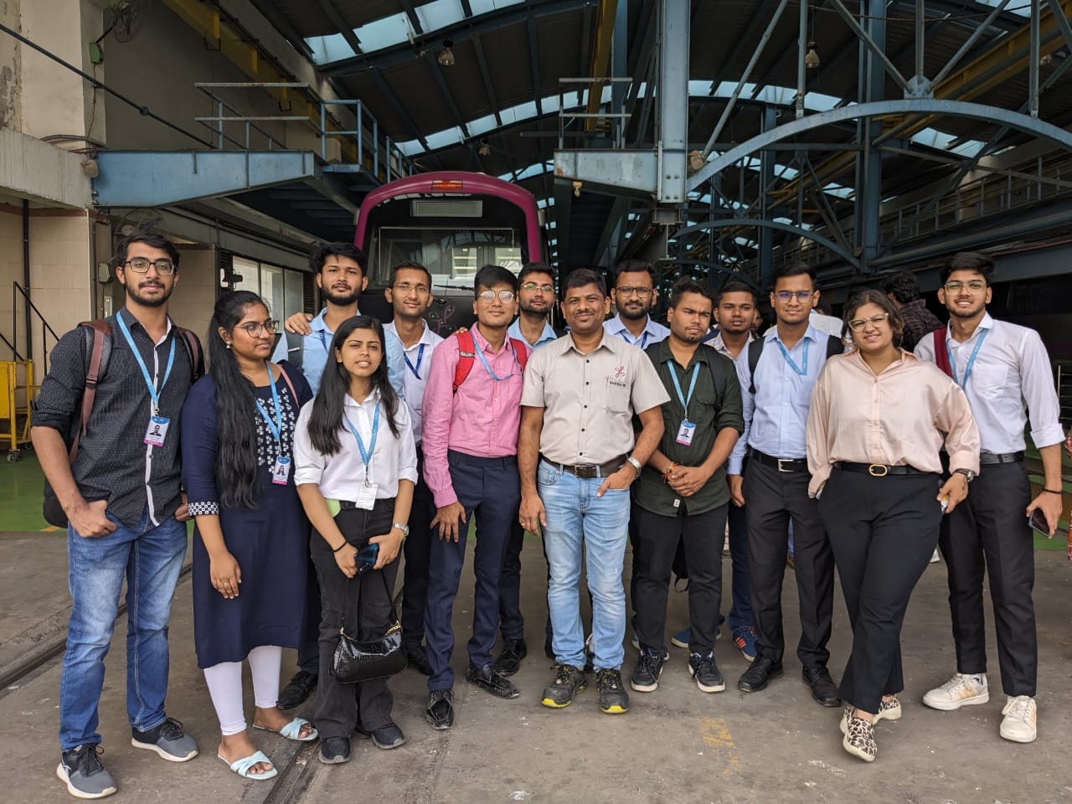

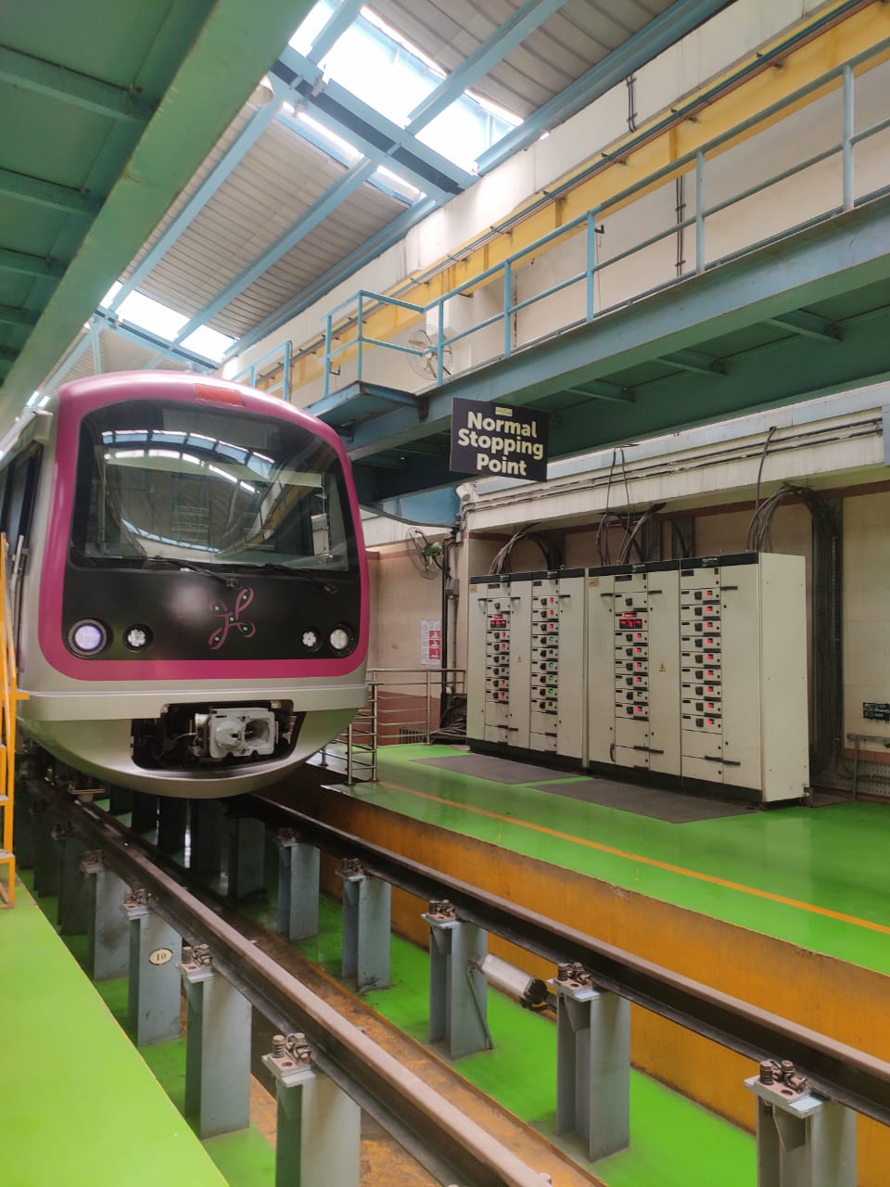

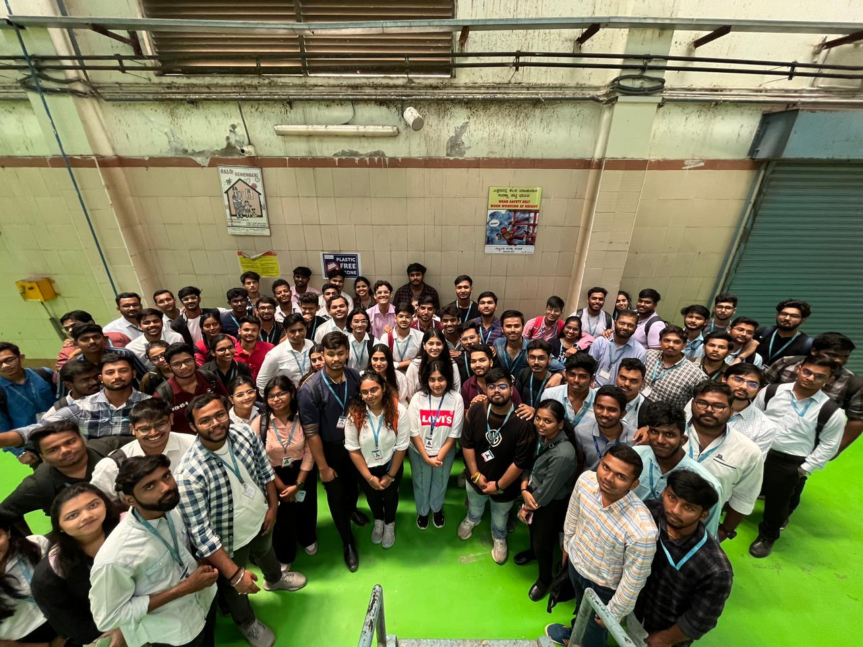

* + - Feedback of the day – 3

**Day – 4 report**

* + - Industry Name – Bangalore Darshini
    - Objectives - Learn about culture & Heritage of Banglore
    - Learning outcome- 1. Tipu sultan place and its significance of wood. 2. Bangalore Palace 3.Iskcon Temple 4. laalbagh botanical - various breed of flowers
    - Photographs (Paste 4-5 good photogrpahs of hands on experience/visit)

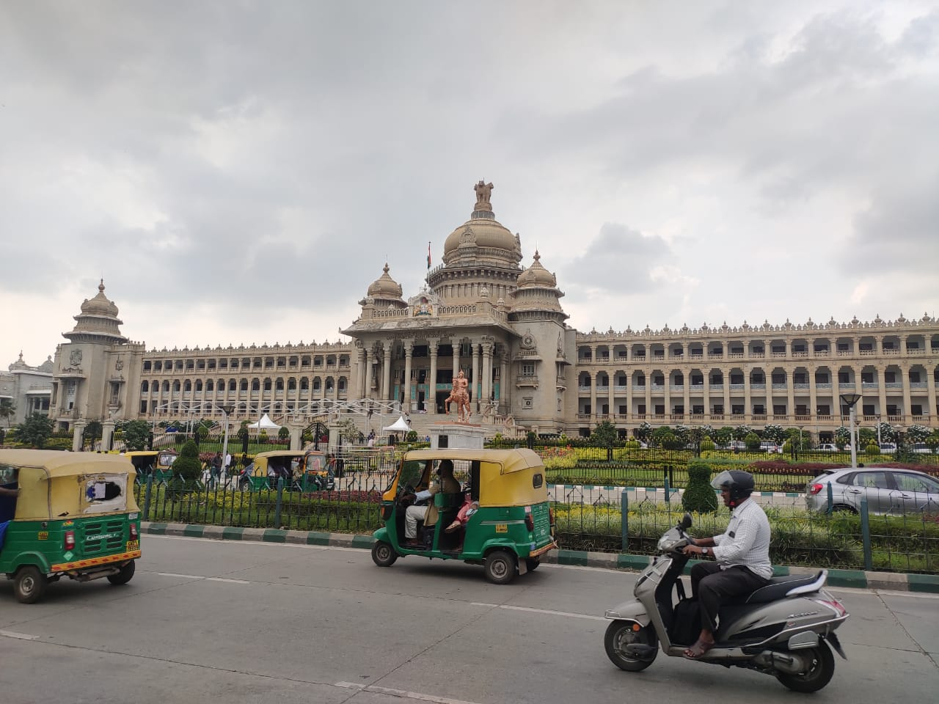

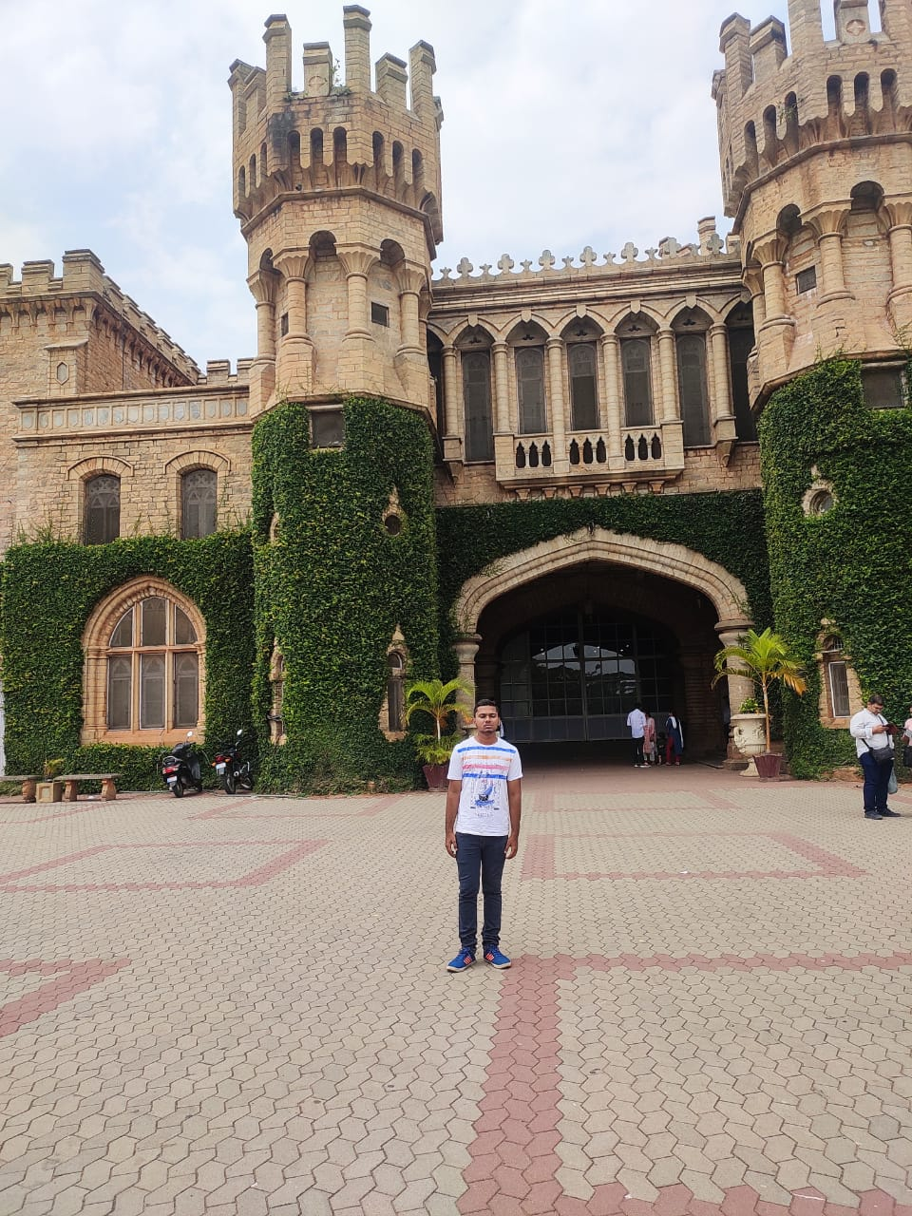

* + - 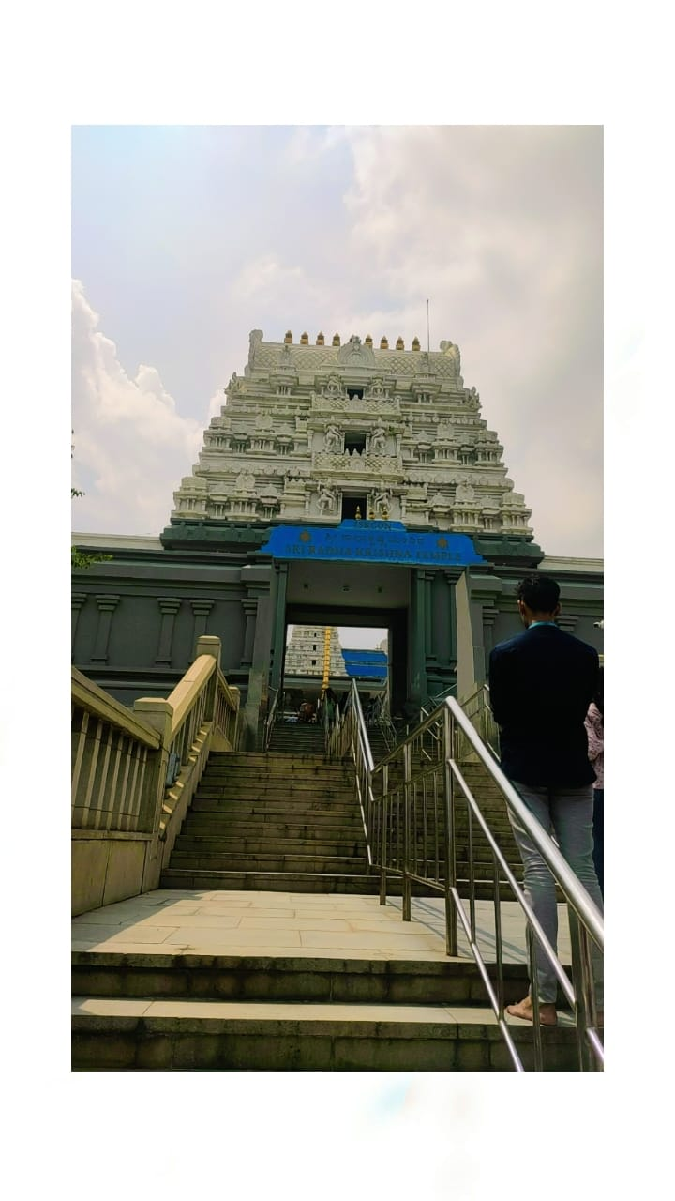Feedback of the day – 4

**Day – 5 report**

* + - Event/Industry Name – Tech Talks - Vijaykiran Convention Centre
    - Objectives- Learn about new technologies
    - Learning outcome- 1. Learned about technologies like cloud computing, Devops . 2. How to make carrer in new fields .
    - Photographs (Paste 4-5 good photogrpahs of hands on experience/visit)

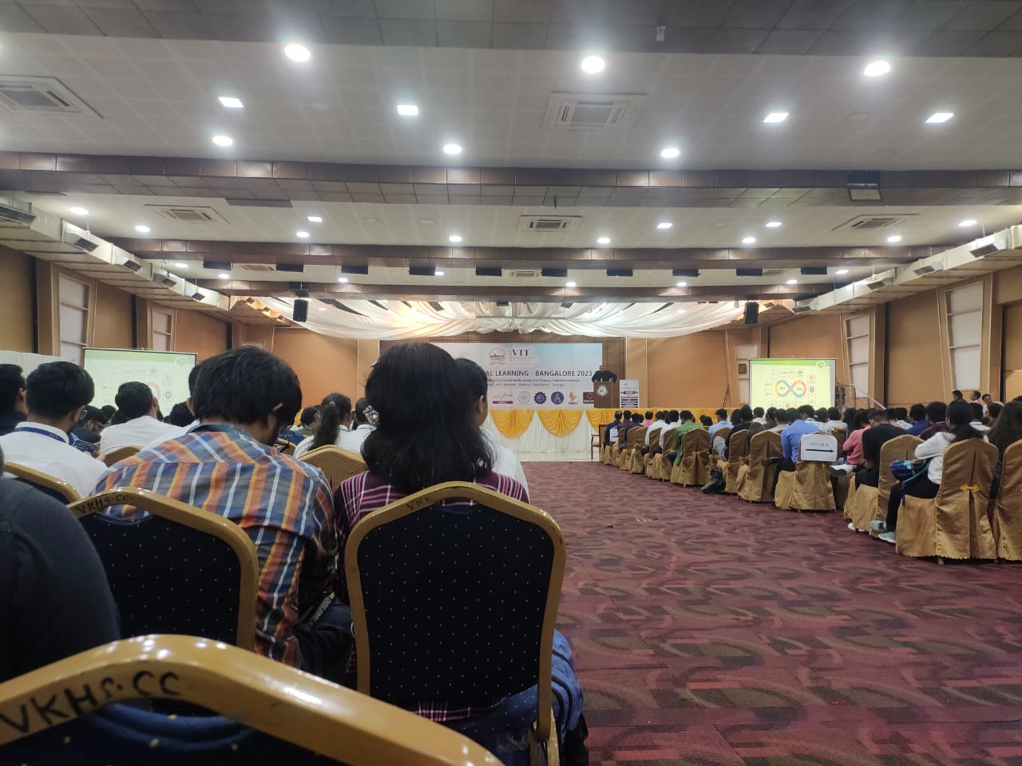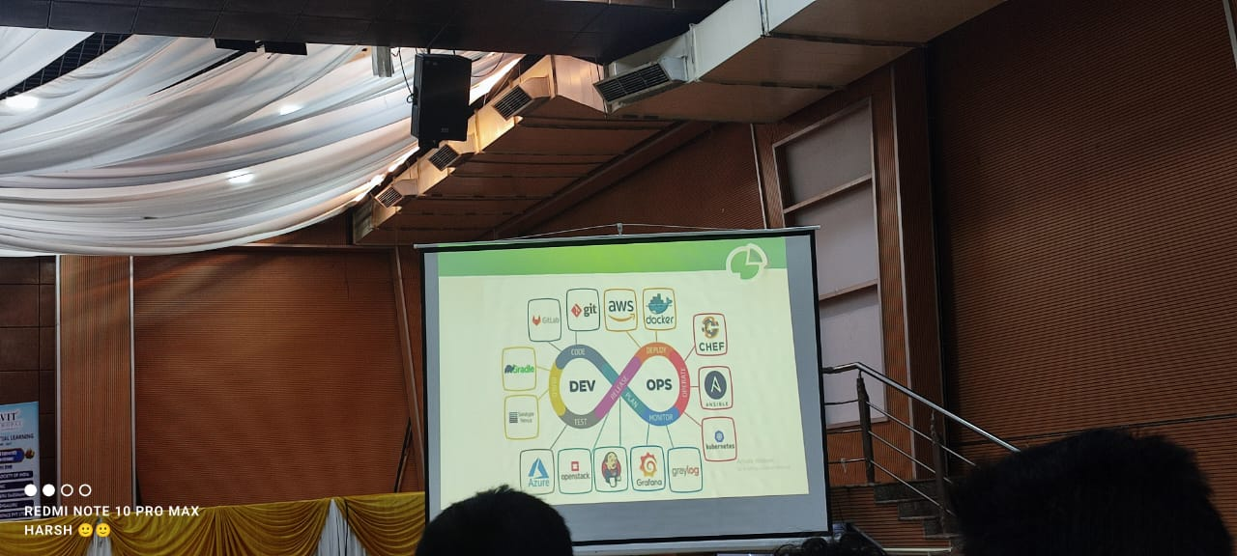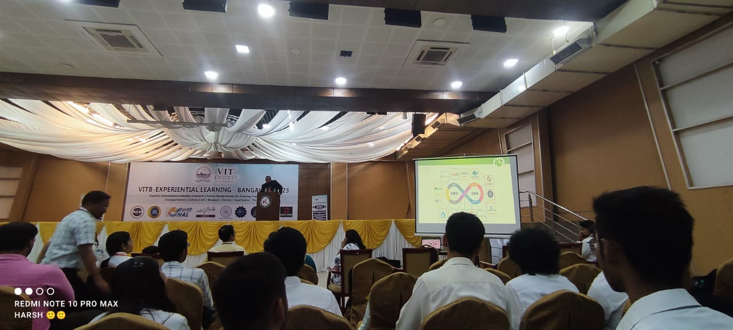

**Conclusions**

[As a conclusion, you need to identify three problem statements and write the same here. It must be derived from your programme proceedings]

* 1.Enhancing Public Transportation Efficiency: Problem Statement: In rapidly growing urban areas like Bangalore, the demand for efficient and sustainable public transportation is rising. How can we develop and implement innovative solutions to enhance the efficiency and accessibility of public transportation systems, reducing traffic congestion and environmental impact?
* 2.Fostering Innovation and Entrepreneurship: Problem Statement: While the "Motivate to Innovate Talks" were inspiring, there's a challenge in translating inspiration into action. How can we create a supportive ecosystem that fosters innovation and encourages entrepreneurship among students and aspiring entrepreneurs?
* 3.Digital Inclusion and Connectivity: Problem Statement: The visit to BSNL highlighted the importance of connectivity in a digitally driven world. However, many regions in India still lack adequate digital infrastructure. How can we address the digital divide and ensure that all communities, especially in rural areas, have access to reliable and affordable internet services?
* 4. Traffic Jam- In Metro cities like Banglore and Chennai Traffic is very big problem . People have to wait for hours to reach their destination. Its mainly because of use of personal Vehicles and not using public transport on daily basis.
* To solve this problem we neeed to make public transport luxury and adequate.